ECA5802-IOE AND AI DRIVEN SYSTEM
EXPERIMENT 5(B): MODELLING AND SIMULATION OF 4 LAYER IOE ARCHITECTURE (PERCEPTION,NETWORK-MIDDLEWARE-APPKICATION) USING NODE RED,MQTT AND CLOUD DASHBOARD

OBJECTIVES:
- To model and simulate the four-layer IoE architecture consisting of Perception, Network, Middleware, and Application layers using Node-RED.
- To collect sensor data and transmit it through MQTT for communication between the IoE layers.
- To process and integrate the collected data using Node-RED and MQTT.
- To visualize real-time sensor data on a cloud dashboard for remote monitoring and analysis.
SOFTWARE REQUIRED:
NODE.JS,MOSQUITTO,NODE.RED

PROGRAM CODE:
var data = msg.payload;

// Convert JSON string to object if necessary
if (typeof data === "string") {
data = JSON.parse(data);
}

msg.payload = {
temperature: Number(data.temperature),
humidity: Number(data.humidity),
timestamp: new Date().toISOString()
};

return msg;
var data = msg.payload;

// Convert JSON string to object if necessary
if (typeof data === "string") {
data = JSON.parse(data);
}

msg.payload = {
temperature: Number(data.temperature),
humidity: Number(data.humidity),
timestamp: new Date().toISOString()
};

return msg;
var data = msg.payload;

var temperature = Number(data.temperature);
var humidity = Number(data.humidity);

var temperatureStatus = temperature > 35 ? "HIGH" : "NORMAL";
var humidityStatus = humidity > 70 ? "HIGH" : "NORMAL";

msg.payload = {
temperature: temperature,
humidity: humidity,
temperatureStatus: temperatureStatus,
humidityStatus: humidityStatus,
overallStatus: (temperatureStatus === "HIGH" || humidityStatus === "HIGH")
? "WARNING"
: "NORMAL",
timestamp: data.timestamp || new Date().toISOString()
};
return msg;
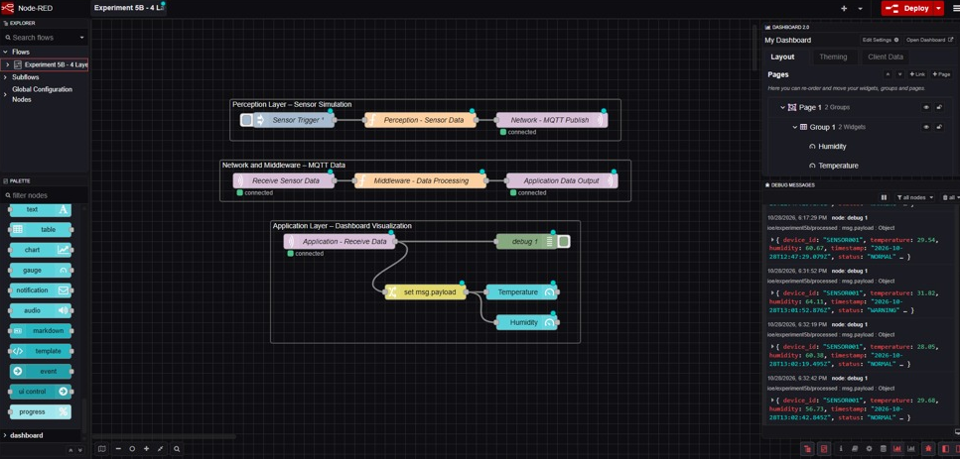
OUTPUT :
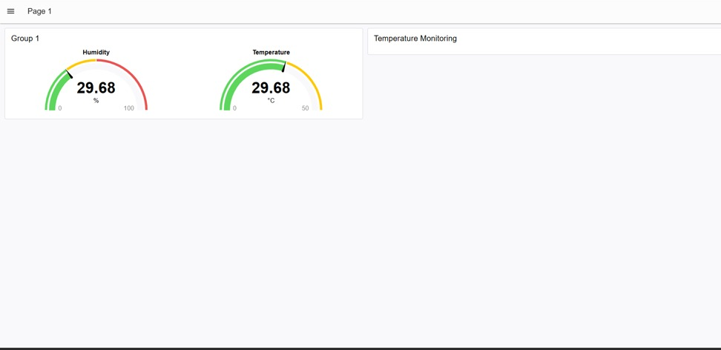
RESULT:
The four-layer IoE architecture was successfully modelled and simulated using Node-RED and MQTT. Sensor data was collected, transmitted, processed, and displayed on a cloud dashboard, demonstrating successful data flow and real-time monitoring across all four layers.

